Major Project On

**A CLASSIFICATION MODEL** **FOR WATER QUALITY ANALYSIS USING DECISION TREE**

(Submitted in partial fulfillment of the requirements for the award of Degree)

BACHELOR OF TECHNOLOGY

In

###### COMPUTER SCIENCE AND ENGINEERING

By

ROHIT MOON (177R1A05G4)

MOHAMMAD UMER (197R1A05Q1)

Under the Guidance of

**SUMA S**

(Assistant Professor)



##### DEPARTMENT OF COMPUTER SCIENCE AND ENGINEERING

**CMR TECHNICAL CAMPUS UGC AUTONOMOUS**

(Accredited by NAAC, NBA, Permanently Affiliated to JNTUH, Approved by AICTE, New Delhi) Recognized Under Section 2(f) & 12(B) of the UGCAct.1956, Kandlakoya (V), Medchal Road, Hyderabad-501401.

**2019-2023**

**DEPARTMENT OF COMPUTER SCIENCE AND ENGINEERING**



#### CERTIFICATE

This is to certify that the project entitled **“A CLASSIFICATION MODEL FOR WATER QUALITY ANALYSIS USING DECISION TREE ”** being submitted by **ROHIT MOON (177R1A05G4) & MOHAMMAD UMER (197R1A05Q1)** inpartial fulfillment of the requirements for the award of the degree of B.Tech in Computer Science and Engineering to the CMR Technical Campus, is a record of bonafide work carried out by them under our guidance and supervision during the year 2022-2023.

The results embodied in this thesis have not been submitted to any other University or Institute for the award of any degree or diploma.

**Suma S Dr. A. Raji Reddy**

(Assistant Professor) DIRECTOR

INTERNAL GUIDE

**Dr. K. Srujan Raju EXTERNAL EXAMINER**

HOD

**Submitted for viva voice Examination held on**

##### ACKNOWLEDGEMENT

Apart from the efforts of us, the success of any project depends largely on the encouragement and guidelines of many others. We take this opportunity to express our gratitude to the people who have been instrumental in the successful completion of this project.

We take this opportunity to express my profound gratitude and deep regard to our guide **Suma S,** AssistantProfessor of CSE for his exemplary guidance, monitoring and constant encouragement throughout the project work. The blessing, help and advice given by him shall carry us a long way in the journey of life on which we are about to embark.

We also take this opportunity to express a deep sense of gratitude to the Project Review Committee (PRC) **Dr. Punyaban Patel, Ms. K. Shilpa, Dr. M. Subha Mastan Rao & J. Narasimharao** for their cordial support, valuable information and guidance, which helped us in completing this task through various stages.

We are also thankful to **Dr. K. Srujan Raju,** Head of the Department of Computer Science and Engineering, **Dr. Ashuthosh Saxena**, Dean R&D, and **Dr. D T V Dharmajee Rao**, Dean Academics for providing encouragement and support for completing this project successfully.

We are obliged to **Dr. A. Raji Reddy,** Director for being cooperative throughout the course of this project. We also express our sincere gratitude to Sri. **Ch. Gopal Reddy,** Chairman for providing excellent infrastructure and a nice atmosphere throughout the course of this project.

The guidance and support received from all the members of **CMR Technical Campus** who contributed to the completion of the project. We are grateful for their constant support and help.

Finally, we would like to take this opportunity to thank our family for their constant encouragement, without which this assignment would not be completed. We sincerely acknowledge and thank all those who gave support directly and indirectly in the completion of this project.

**ROHIT MOON (177R1A05G4)**

**MOHAMMAD UMER (197R1A05Q1)**

##### ABSTRACT

A classification algorithm is used to assign predefined classes to test instances for evaluation) or future instances to an application). This study presents a Classification model using decision tree for the purpose of analyzing water quality data from different counties in Kenya. The water quality is very important in ensuring citizens get to drink clean water. Application of decision tree as a data mining method to predict clean water based on the water quality parameters can ease the work of the laboratory technologist by predicting which water samples should proceed to the next step of analysis. The secondary data from Kenya Water institute was used for creation of this model. The data model was implemented in WEKA software. Classification using decision tree was applied to classify /predict the clean and not clean water. The analysis of water Alkalinity level and conductivity can play a major role in assessing water quality. Five decision tree classifiers which are J48, LMT, Random forest, Hoeffding tree and Decision Stump were used to build the model and the accuracy compared. J48 decision tree had the highest accuracy of 94% with Decision Stump having the lowest accuracy of 83%.

##### FIGURE NO FIGURE NAME PAGE NO

###### Figure 3.1 Project Architecture for water 7

###### quality analysis

###### Figure 5.2 Working of Random forest 10

###### 

###### Figure 5.3 Decision tree classifier 13

###### Figure 5.4 Use case Diagram for water 15

###### quality analysis

###### Figure 5.5 Class diagram for water 16

###### quality analysis

###### Figure 5.6 Sequence diagram for water 17

###### Quality analysis

###### Figure 5.6 Activity diagram for water 18

###### Quality analysis

|  |  |  |
| --- | --- | --- |
| **SCREENSHOT NO** | **SCREENSHOT NAME** | **PAGE NO** |
| SCREENSHOT 5.1 | OPENING THE APPLICATION | 44 |
| SCREENSHOT 5.2 | RUNNING THE APPLICATION | 45 |
|  |  |  |
| SCREENSHOT 5.3 | USER INTERFACE OF  THE APPLICATION | 46 |
|  |  |  |
| SCREENSHOT 5.4 | INPUT VALUES | 47 |
|  |  |  |
| SCREENSHOT 5.5 | RESULT OF INPUT VALUES | 48 |
|  |  |  |
| SCREENSHOT 5.6 | RESULT OF INPUT VALUES | 49 |

iii

# TABLE OF CONTENTS

ABSTRACT i

|  |  |
| --- | --- |
| **LIST OF FIGURES** | ii |
| **LIST OF SCREENSHOTS** | iii |
| **1.INTRODUCTION** | 1 |
| 1.1 PROJECT SCOPE | 1 |
| 1.2 PROJECT PURPOSE | 1 |
| 1.3 PROJECT FEATURE | 1 |
| **2.SYSTEM ANALYSIS** | 2 |
| 2.1 PROBLEM DEFINITION | 2 |
| 2.2 EXISTING SYSTEM | 2 |
| 2.2.1 LIMITATIONS OF THE EXISTING SYSTEM | 3 |
| 2.3 PROPOSED SYSTEM | 3 |
| 2.3.1 ADVANTAGES OF PROPOSED SYSTEM | 3 |
| 2.4 FEASIBILITY STUDY | 4 |
| 2.4.1 ECONOMIC FEASIBILITY | 4 |
| 2.4.2 TECHNICAL FEASIBILITY | 5 |
| 2.4.3 BEHAVIOURAL FEASIBILITY | 5 |
| 2.5 HARDWARE & SOFTWARE REQUIREMENTS | 6 |
| **3.ARCHITECTURE** | 7 |
| 3.1 PROJECT ARCHITECTURE | 7 |
| 3.2 USE CASE DIAGRAM | 15 |
| 3.3 CLASS DIAGRAM | 16 |
| 3.4 SEQUENCE DIAGRAM | 17 |
| 3.5 ACTIVITY DIAGRAM | 18 |
| **4.IMPLEMENTATION** | 19 |
| 4.1 SOURCE CODE | 28 |
| **5.RESULTS**  5.1 OPENING THE APPLICATION | 29  29 |
| 5.2 RUNNING THE APPLICATION | 30 |
| 5.3 USER INTERFACE OF THE APPLICATION | 31 |
| 5.4 INPUT VALUES | 32 |
| 5.5 RESULT OF INPUT VALUES | 33 |
| 5.6 RESULT OF INPUT VALUES | 34 |
| **6.TESTING** | 34 |
| 6.1 INTRODUCTION TO TESTING | 34 |
| 6.2 TYPES OF TESTING | 34 |
| 6.2.1 UNIT TESTING | 34 |
| 6.2.2 INTEGRATION TESTING | 35 |
| 6.2.3 FUNCTIONAL TESTING | 36 |
| 6.3 TEST CASES | 36 |
| 6.3.1 CLASSIFICATION | 38 |
| **7.CONCLUSION** | 38 |
| 7.1 PROJECT CONCLUSION | 38 |
| 7.2 FUTURE SCOPE | 39 |
| **8.BIBLIOGRAPHY** | 39 |
| 8.1 REFERENCE | 39 |
| 8.2 GITHUB LINK | 40 |
| **9. PAPER PUBLICATION** |  |
|  |  |

# INTRODUCTION

#### INTRODUCTION

##### 

##### 1.1 PROJECT SCOPE

This project is titled “A CLASSIFICATION MODEL FOR WATER QUALITY ANALYSIS USING DECISION TREE” In industries, improper quality of water may cause hazards and severe economic loss. Thus, the quality of water is very important in both environmental and economic aspects. Thus, water quality analysis is essential for using it in any purpose.

##### 

##### 1.2 PROJECT PURPOSE

The data analysis tool used in this study is WEKA which is a data mining software developed by the University of Waikato in New Zealand that apparatus data mining algorithms using the JAVA language. Weka is a milestone in the history of the data mining and machine learning research communities, because it is the only toolkit that has gained such widespread adoption.

##### 1.3 PROJECT FEATURES

The main feature of this project is that this Algorithms like Random forest, FT Tree, LAD Tree, decision stamp, LMT. This is more Accuracy. User friendly UI using Flask.

## SYSTEM ANALYSIS

##### SYSTEM ANALYSIS

**SYSTEM ANALYSIS**

System Analysis is the important phase in the system development process. The System is studied to the minute details and analyzed. The system analyst plays an important role of an interrogator and dwells deep into the working of the present system. In analysis, a detailed study of these operations performed by the system and their relationships within and outside the system is done. A key question considered here is, “what must be done to solve the problem?” The system is viewed as a whole and the inputs to the system are identified. Once analysis is completed the analyst has a firm understanding of what is to be done.

##### PROBLEM DEFINITION

The problems in this project are this system uses a smaller number of algorithms to build model. Accuracy is less and performance is not optimized.

##### EXISTING SYSTEM

Muharemi et al., 2018 proposed the Nearest Neighbor Algorithm (KNN) and the Neural Network of Classification based on Logistic Regression to obtain an adequate solution to address the problem of changes in the quality of drinking water. Haghiabi et al., (2018) investigated the performance of artificial intelligence techniques that include the artificial neural network (ANN),the group data management method (GMDH) and the support vector machine (SVM) to predict the components of the water quality of the Tireh River located in southwestern Iran.

Zhang et al., (2017) proposed a new anomaly detection algorithm for water quality data using double-movement windows over time, which can identify historical pattern anomaly data in real time. The algorithm is based on statistical models, autoregressive linear combination model. The algorithm has been tested using water quality PH data at 3 months from a real water quality monitoring station on a river system. The experimental results show that their algorithms can significantly decrease the false positive rate and have a better anomaly detection performance than the AD and ADAM algorithms.

* + 1. LIMITATIONS OF EXISTING SYSTEM
* This system uses a smaller number of algorithms to build model.
* Accuracy is less and performance is not optimized.

**Limitations of existing algorithms**

* + Decision Tree:
  + Less effective in predicting the outcome of a continuous variable: Decision trees are best for categorical variables because they divide the data according to a set of rules. They may not perform as well for continuous variables, however, because the splitting rules may be unable to capture the complexities of the data.
  + Prone to overfitting: Decision trees are prone to overfitting, which means they fit the data too closely to the training data and may not generalise well to new, unseen data. This is especially true if the decision tree is lengthy or complicated.

##### PROPOSED SYSTEM

The data analysis tool used in this study is WEKA which is a data mining software developed by the University of Waikato in New Zealand that apparatus data mining algorithms using the JAVA language. Weka is a milestone in the history of the data mining and machine learning research communities, because it is the only toolkit that has gained such widespread adoption.

Various decision tree algorithms are used in classification like ID3, AD Tree, REP, J48, FT Tree, LAD Tree, decision stamp, LMT, random forest, random tree etc. In this work the decision trees which considered are J48, LMT, Random Forest and Random

tree for comparison purposes and all those decision tree algorithms are found in WEKA.

* + 1. ADVANTAGES OF THE PROPOSED SYSTEM
* Algorithms like Random forest, FT Tree, LAD Tree, decision stamp, LMT.
* Accuracy is more than existing system.
* User friendly UI using Flask.

##### FEASIBILITY STUDY

The feasibility of the project is analyzed in this phase and a business proposal is put forth with a very general plan for the project and some cost estimates. During system analysis the feasibility study of the proposed system is to be carried out. This is to ensure that the proposed system is not a burden to the company. Three key considerations involved in the feasibility analysis:

* Economic Feasibility
* Technical Feasibility
* Social Feasibility
  + 1. ECONOMIC FEASIBILITY

The developing system must be justified by cost and benefit. Criteria to ensure that effort is concentrated on a project, which will give best, return at the earliest. One of the factors, which affect the development of a new system, is the cost it would require.

The following are some of the important financial questions asked during preliminary investigation:

* The costs conduct a full system investigation.
* The cost of the hardware and software.
* The benefits in the form of reduced costs or fewer costly errors.

Since the system is developed as part of project work, there is no manual cost to spend for the proposed system. Also all the resources are already available, it give an indication that the system is economically possible for development.

* + 1. TECHNICAL FEASIBILITY

This study is carried out to check the technical feasibility, that is, the technical requirements of the system. Any system developed must not have a high demand on the available technical resources. The developed system must have a modest requirement, as only minimal or null changes are required for implementing this system.

* + 1. SOCIAL FEASIBILITY

This includes the following questions:

* Is there sufficient support for the users?
* Will the proposed system cause harm?

The project would be beneficial because it satisfies the objectives when developed and installed. All behavioral aspects are considered carefully and conclude that the project is behaviorally feasible.

##### HARDWARE & SOFTWARE REQUIREMENTS

* + 1. HARDWARE REQUIREMENTS:

Hardware interfaces specify the logical characteristics of each interface between the software product and the hardware components of the system. The following are some hardware requirements.

* Processor : Intel Core i3 or higher
* Hard Disk : 4 GB or higher
* Memory : 512 Mb and higher
* GPU : minimum of 2GB - VRAM

##### 2.5.2 SOFTWARE REQUIREMENTS:

Software Requirements specifies the logical characteristics of each interface

and software components of the system.

The following are some software requirements.

* Operating Systems : Windows 10 or higher / Ubuntu 16.04 or higher
* Programming Language : Python 3.7 or higher
* Python IDE : Anaconda, PyCharm or Spyder

## ARCHITECTURE

##### 3. ARCHITECTURE

##### 3.1 PROJECT ARCHITECTURE

This project architecture shows the procedure how text is converted into code and speech is converted in to text

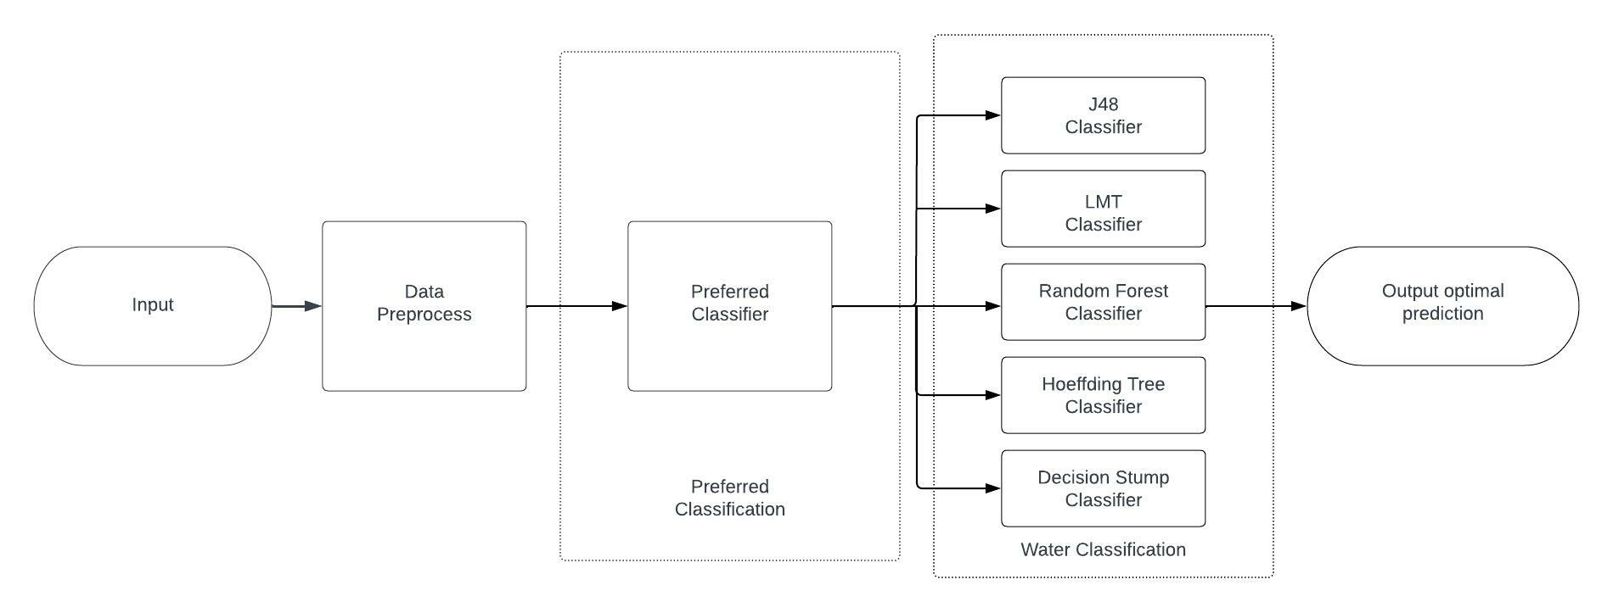

Figure 3.1: Architecture

3.1.1 DESCRIPTION

In This project we using Five decision tree classifiers which are J48, LMT, Random forest, Hoeffding tree and Decision Stump were used to build the model and the accuracy compared. From input values to get prediction values of water quality.

3.1.2 WORKING

Data Collection and Preprocessing: Gather a dataset containing water quality data such as pH, temperature, turbidity, dissolved oxygen, biochemical oxygen demand (BOD), etc. from different sources. Clean the data by removing missing values, outliers, and any duplicates. Normalize the features to ensure that all features are on a similar scale.

Data Splitting: Divide the dataset into two parts, a training set and a testing set. The training set will be used to train the model, while the testing set will be used to evaluate the model's performance.

Decision Tree Algorithm: The decision tree algorithm is a supervised learning algorithm that can be used for both classification and regression tasks. In this case, we will use it for classification. We will use the scikit-learn library in Python to implement the decision tree algorithm.

Train the Model: Train the decision tree algorithm on the training data using the fit() function in scikit-learn. The decision tree will learn from the features in the training data and build a tree-like model.

Evaluate the Model: Use the testing set to evaluate the performance of the model. Use metrics such as accuracy, precision, recall, and F1 score to evaluate the model's performance.

Tune the Model: The decision tree algorithm has several hyperparameters that can be tuned to improve the model's performance. Some of the hyperparameters include max_depth, min_samples_split, and criterion. Use techniques such as grid search and cross-validation to find the best hyperparameters for the model.

Deploy the Model: Once you have tuned the model and achieved satisfactory performance, you can deploy the model in production. You can use the trained model to classify new water quality samples based on their features.

**3.1.3 MODULES**

NumPy: NumPy is a Python library used for working with arrays. You will use NumPy to manipulate the data and perform calculations.

Pandas: Pandas is a Python library used for data manipulation and analysis. You will use Pandas to load the water quality dataset, clean the data, and prepare it for the model.

Scikit-learn: Scikit-learn is a machine learning library for Python that provides various algorithms for classification, regression, clustering, and dimensionality reduction. You will use scikit-learn to implement the decision tree algorithm.

Matplotlib: Matplotlib is a plotting library for Python. You will use Matplotlib to visualize the data and the decision tree model.

**3.1.4 RANDOM FOREST CLASSIFIER :**

A Random Forest Algorithm is a supervised machine learning algorithm that is extremely popular and is used for Classification and Regression problems in Machine Learning. We know that a forest comprises numerous trees, and the more trees more it will be robust. Similarly, the greater the number of trees in a Random Forest Algorithm, the higher its accuracy and problem-solving ability. Random Forest is a classifier that contains several decision trees on various subsets of the given dataset and takes the average to improve the predictive accuracy of that dataset. It is based on the concept of ensemble learning which is a process of combining multiple classifiers to solve a complex problem and improve the performance of the model**.**

**WORKING OF RANDOM FOREST :**

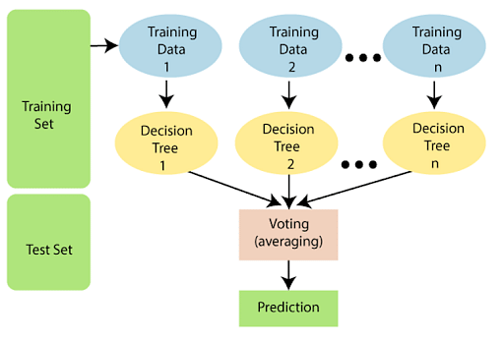

The following steps explain the working Random Forest Algorithm:

Step 1: Select random samples from a given data or training set.

Step 2: This algorithm will construct a decision tree for every training data.

Step 3: Voting will take place by averaging the decision tree.

Step 4: Finally, select the most voted prediction result as the final prediction result.

**3.1.5 J48 CLASSIFIER :**

J48 classifier is a decision tree algorithm that is implemented in the Weka machine learning software. It is based on the C4.5 algorithm, which builds decision trees by recursively splitting the data based on the feature that provides the most information gain.The J48 algorithm works by selecting the feature that provides the most information gain at each node in the decision tree. Information gain is a measure of the reduction in entropy (i.e., uncertainty) achieved by splitting the data on a particular feature. The algorithm then recursively splits the data based on the selected feature until all the data points at a given node belong to the same class or the maximum depth of the tree is reached.

Here's an example of how to use J48 classifier in Weka:

1. Load the dataset: Load the dataset in Weka by going to File -> Open and selecting the dataset file.
2. Preprocess the data: Preprocess the data if necessary, by cleaning the data, handling missing values, and converting categorical variables to numerical form.
3. Train the J48 classifier: Select J48 as the classifier from the Weka Explorer panel and set the options for the classifier, such as the number of folds for cross-validation and the pruning options.
4. Evaluate the classifier: Evaluate the accuracy of the classifier by running a 10-fold cross-validation on the dataset and examining the performance measures such as accuracy, precision, recall, and F1 score.

**3.1.6 LMT CLASSIFIER :**

The LMT (Logistic Model Tree) classifier is a machine learning algorithm that combines decision trees and logistic regression to create a more accurate classification model.The LMT classifier works in two stages. In the first stage, the algorithm builds a decision tree to partition the data into smaller subsets based on a set of rules. Each node in the decision tree represents a feature or attribute of the dataset, and the edges between nodes represent the decision rules based on that feature.

In the second stage, logistic regression is used to build a classification model for each subset of the data defined by the decision tree. The logistic regression models predict the probability of the target class based on the values of the features in that subset. The final prediction for a new instance is then determined by traversing the decision tree and using the corresponding logistic regression model to make a prediction.

LMT is particularly useful for datasets with a large number of features or a high degree of complexity, as it can handle interactions between features and reduce the risk of overfitting. By combining decision trees and logistic regression, LMT can capture both linear and non-linear relationships between the features and the target variable, making it a powerful classification algorithm.

**3.1.7 HOEFFDING TREE CLASSIFIER :**

The Hoeffding tree algorithm is a decision tree learning method for stream data classification. It was initially used to track Web clickstreams and construct models to predict which Web hosts and Web sites a user is likely to access. It typically runs in sublinear time and produces a nearly identical decision tree to that of traditional batch learners.It uses Hoeffding trees, which exploit the idea that a small sample can often be enough to choose an optimal splitting attribute

. This idea is supported mathematically by the Hoeffding bound (or additive Chernoff bound).Suppose we make N independent observations of a random variable r with range R, where r is an attribute selection measure. (For a probability, R is one, and for an information gain, it is log c, where c is the number of classes.) In the case of Hoeffding trees, r is information gain. If we compute the mean, r’, of this sample, the Hoeffding bound states that the true mean of r is at least r’−ε, with probability 1−δ, where δ is user-specified.

The Hoeffding Tree algorithm uses the Hoeffding bound to determine, with high probability, the smallest number, N, of examples needed at a node when selecting a splitting attribute. The Hoeffding bound is independent of the probability distribution, unlike most other bound equations. This is desirable, as it may be impossible to know the probability distribution of the information gain, or whichever attribute selection measure is used.

The algorithm takes as input a sequence of training examples, S, described by attributes A, and the accuracy parameter, δ. The evaluation function G(Ai) is supplied, which could be information gain, gain ratio, Gini index, or some other attribute selection measure. At each node in the decision tree, we need to maximize G (Ai) for one of the remaining attributes,Ai. The goal is to find the smallest number of tuples, N, for which the Hoeffding bound is satisfied.

The algorithm takes as input a sequence of training examples, S, described by attributes A, and the accuracy parameter, δ. The evaluation function G(Ai) is supplied, which could be information gain, gain ratio, Gini index, or some other attribute selection measure. At each node in the decision tree, we need to maximize G (Ai) for one of the remaining attributes,Ai. The goal is to find the smallest number of tuples, N, for which the Hoeffding bound is satisfied.

For a given node, let Aa be the attribute that achieves the highest G, and Abbe the attribute that achieves the second-highest G. If G(Aa ) − G(Ab) > ε, where ε is calculated. The only statistics that must be maintained in the Hoeffding tree algorithm are the counts nijk for the value vj of attribute Ai with class label yk. Therefore, if d is the number of attributes, v is the maximum number of values for any attribute, c is the number of classes, and l is the maximum depth (or the number of levels) of the tree, then the total memory required is O (ldvc).

**3.1.8** **DECISION TREE CLASSIFIER :**

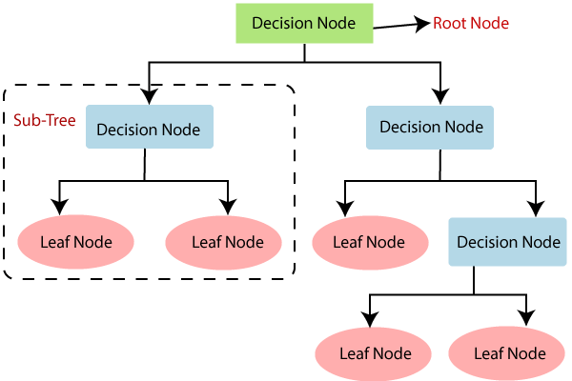

* Decision Tree is a Supervised learning technique that can be used for both classification and Regression problems, but mostly it is preferred for solving Classification problems. It is a tree-structured classifier, where internal nodes represent the features of a dataset, branches represent the decision rules and each leaf node represents the outcome.
* In a Decision tree, there are two nodes, which are the Decision Node and Leaf Node. Decision nodes are used to make any decision and have multiple branches, whereas Leaf nodes are the output of those decisions and do not contain any further branches.
* The decisions or the test are performed on the basis of features of the given dataset.
* It is a graphical representation for getting all the possible solutions to a problem/decision based on given conditions.
* It is called a decision tree because, similar to a tree, it starts with the root node, which expands on further branches and constructs a tree-like structure.
* In order to build a tree, we use the CART algorithm, which stands for Classification and Regression Tree algorithm.
* A decision tree simply asks a question, and based on the answer (Yes/No), it further split the tree into subtrees.

**Why use Decision Trees?**

There are various algorithms in Machine learning, so choosing the best algorithm for the given dataset and problem is the main point to remember while creating a machine learning model. Below are the two reasons for using the Decision tree:

* + Decision Trees usually mimic human thinking ability while making a decision, so it is easy to understand.
* The logic behind the decision tree can be easily understood because it shows a tree-like structure.

3.2 USE CASE DIAGRAM

A use case diagram is a graphical depiction of a user's possible interactions with a system. A use case diagram shows various use cases and different types of users the system has. The use cases are represented by either circles or ellipses. The actors are often shown as stick figures or we can also say a use case diagram is a type of behavioral diagram that is used to represent the interactions between users (actors) and a system or application. It provides a graphical representation of the system's functionality by illustrating the different use cases and actors involved in the system.

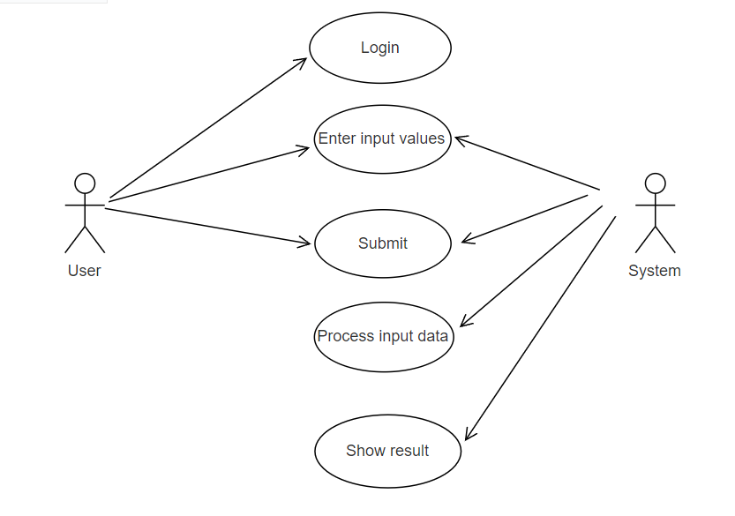

Figure 3.4: Use Case Diagram

##### 3.3 CLASS DIAGRAM

A class diagram is a type of structural diagram in UML (Unified Modeling Language) that represents the classes and objects in a system, along with their attributes and relationships with other classes/objects. the class diagram would represent the various classes involved in the system, such as:

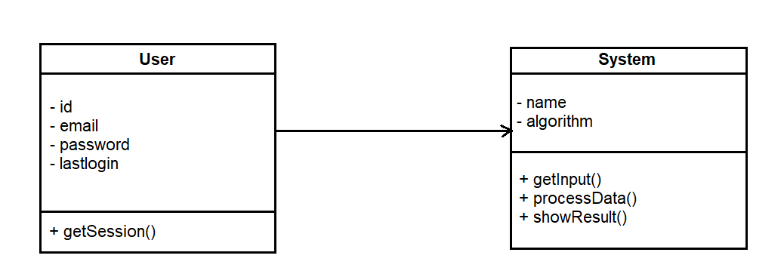

Figure 3.5: Class Diagram

##### 3.4 SEQUENCE DIAGRAM

A sequence diagram shows object interactions arranged in time sequence. It depicts the objects involved in the scenario and the sequence of messages exchanged between the objects needed to carry out the functionality of the scenario. Sequence diagrams are typically associated with use case realizations in the logical view of the system under development. In the context of water quality a sequence diagram can be used to depict the flow of events.

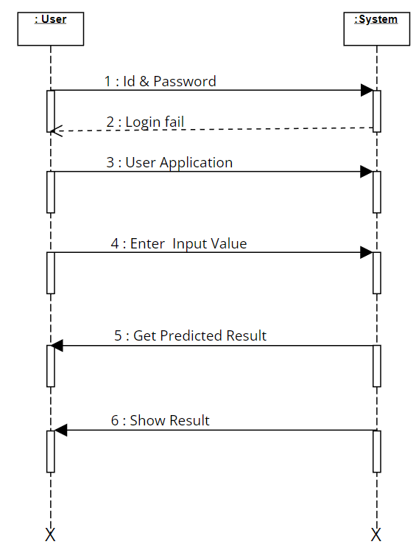

Figure 3.6: Sequence Diagram

3.5 ACTIVITY DIAGRAM

Activity diagrams are graphical representations of workflows of stepwise activities and actions with support for choice, iteration and concurrency. They can also include elements showing the flow of data between activities through one or more data stores. An activity diagram is a UML diagram that models the flow of activities within a system. It is used to depict the dynamic aspects of the system, showing how the system processes data and responds to events.

In the context of the water quality, an activity diagram could be used to illustrate the flow of activities involved weather the water is portabe or not. It could depict the following activities:

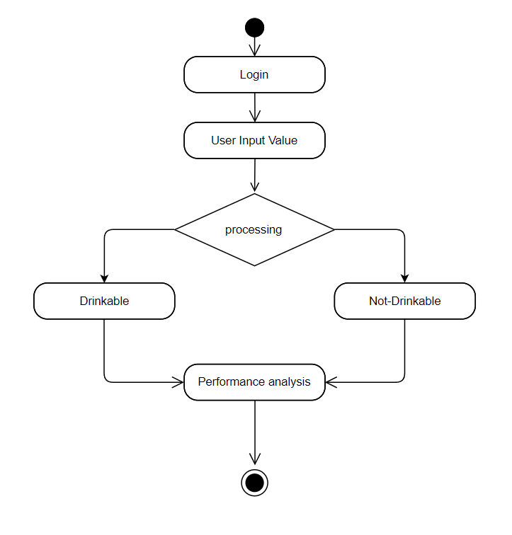

Figure 3.7: Activity Diagram

The activity diagram could show the sequence of activities, the input and output of each activity, and the conditions that trigger the activities. It could also show the actors involved in each activity, such as the user, the application, and the dataset.

**4. IMPLEMENTATION**

**4.IMPLEMENTAION**

**4.1 SAMPLE CODE**

**App.py**

import pickle

from flask import Flask, render_template, request

import numpy as np

import os

app = Flask(__name__)

@app.route('/', methods=['GET', 'POST'])

def home():

if request.method == "POST":

# request all the input fields

ph = float(request.form['ph value'])

Hardness = float(request.form['Hardness'])

Solids = float(request.form['Solids'])

Chloramines = float(request.form['Chloramines'])

Sulfate = float(request.form['Sulfate'])

Conductivity = float(request.form['Conductivity'])

Organic_carbon = float(request.form['Organic carbon'])

Trihalomethanes = float(request.form['Trihalomethanes'])

Turbidity = float(request.form['Turbidity'])

# create numpy array for all the inputs

val = np.array([ph, Hardness, Solids, Chloramines, Sulfate, Conductivity, Organic_carbon, Trihalomethanes, Turbidity])

# define save model and scaler path

model_path = os.path.join('models', 'xgboost.sav')

scaler_path = os.path.join('models', 'scaler.sav')

# load the model and scaler

model = pickle.load(open(model_path, 'rb'))

scc = pickle.load(open(scaler_path, 'rb'))

# transform the input data using pre fitted standard scaler

data = scc.transform([val])

# make a prediction for the given data

res = model.predict(data)

if res == 1:

outcome = 'Potable'

else:

outcome = 'not potable'

return render_template('index.html', result=outcome)

return render_template('index.html')

# run application

if __name__ == "__main__":

app.run(debug=True)

**MAIN PROGRAM**

**sheets.css**

body {

background-image:url('img1.jpg');

font-family: verdana;

background-repeat: no-repeat;

background-size: cover;

animation: loadtransition 2s;

}

h1 {

font-size: 26px;

color: black;

font-family: initial;

padding: 10px;

text-align: center;

}

input{

display: block;

width: 75%;

border: aliceblue;

border-radius: 6px;

outline: 4px;

padding: 7px;

margin: 10px auto;

box-shadow: 0px 0px 13px -5px;

transition: all .25s;

}

input:hover{

margin: 15px auto;

width: 80%;

}

p{

font-size: 20px;

margin: 10px 10px 10px 10px;

color: black

}

form{

background: rgba(255, 255, 255, 0.8);

border-radius: 10px;

position: absolute;

width: 27%;

margin: 1em 30em;

}

div.project{

box-shadow: 0px 7px 60px -10px black;

width: auto ;

font-size: 15px;

border-radius: 10px;

border: 1px soid rgba(255,255,255,0.3)

box-shadow:2px 2px 15px rgba(0,0,0,0.3);

color: #ddd;

width: 400px;

margin: 100px auto 0px auto;

}

center input{

display: inline-block;

background-color: rgba(255, 255, 255);

color: black;

width:25%;

transition: all .25s;

}

input.btn:hover{

background-color: darkgreen;

color: white;

letter-spacing: 2px;

width:30%

}

div.context{

display: inline-block;

width: 40%;

color: black;

position: absolute;

margin: 7em 4em;

font-size: 20px;

font-family: cursive;

background-color: rgba(255,255,255,0.7);

padding: 50px;

border-radius: 15px;

transition: all 1s;

}

div.context:hover{

background-color:grey;

color:white;

padding: 60px;

margin: 8em 4em 1em ;

}

div.name{

display: inline-block;

width: auto;

color: black;

position: absolute;

font-size: 67px;

font-weight: bold;

margin: -0.2em 1em;

color: white;

font-family: cursive;

padding: 0px 0px 0px 100px;

transition: all 1s;

}

div.name:hover{

letter-spacing: 2px;

color:aquamarine;

}

@keyframes loadtransition{

from{

opacity:0;

transform: rotateX(-10deg);

}

to{

opacity:1;

transform: rotateX(0deg);

}

}

**Index.html**

<!doctype html>

<html>

<head>

<link rel= "stylesheet" type= "text/css" href= "{{ url_for('static',filename='styles/stylesheet.css') }}">

<!--for bg image in html file-->

<!--background-image:url({{ url_for('static', filename='img/img1.jpg') }});-->

<title>Water Quality</title>

</head>

<body>

<div class="name">

Water Quality

</div>

<div class="context">

{% if result %}

Given water sample is {{ result }}

{% else %}

"Access to safe drinking-water is essential to health, a basic human right and a component of effective policy for health protection. This is important as a health and development issue at a national, regional and local level. In some regions, it has been shown that investments in water supply and sanitation can yield a net economic benefit, since the reductions in adverse health effects and health care costs outweigh the costs of undertaking the interventions."

{% endif %}

</div>

<div class="project">

<form method="post" action="/" enctype = "multipart/form-data">

<h1 > Potability Checker</h1>

<input type="text" name="ph value" id="ph value" placeholder="ph value(0 to 14)" required>

<input type="text" name="Hardness" id="Hardness" placeholder="Hardness(mg/L)" required>

<input type="text" name="Solids" id="Solids" placeholder="Solids(ppm)" required>

<input type="text" name="Chloramines" id="Chloramines" placeholder="Chloramines(ppm)" required>

<input type="text" name="Sulfate" id="Sulfate" placeholder="Sulfate(mg/L)" required>

<input type="text" name="Conductivity" id="Conductivity" placeholder="Conductivity(uS/cm)" required>

<input type="text" name="Organic carbon" id="Organic carbon" placeholder="Organic carbon(ppm)" required>

<input type="text" name="Trihalomethanes" id="Trihalomethanes" placeholder="Trihalomethanes(ug/L)" required>

<input type="text" name="Turbidity" id="Turbidity" placeholder="Turbidity(NTU)" required>

<center><input class="btn" type=submit name="submit_button" value=PREDICT></center>

</form>

</div>

</body>

</html>

**5. RESULT**

**5. RESULTS**

**5.1: Opening the Application**

Opening of the Application from files

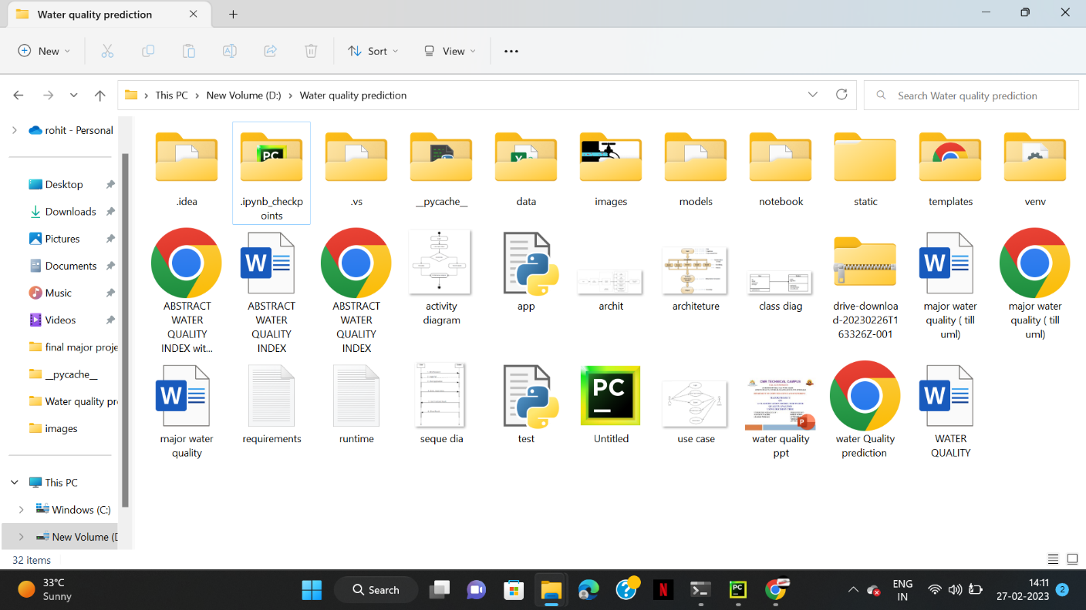

Screenshot 5.1: Opening the Application

**5.2: Running the Application**

As application is a Python file. Running the python file

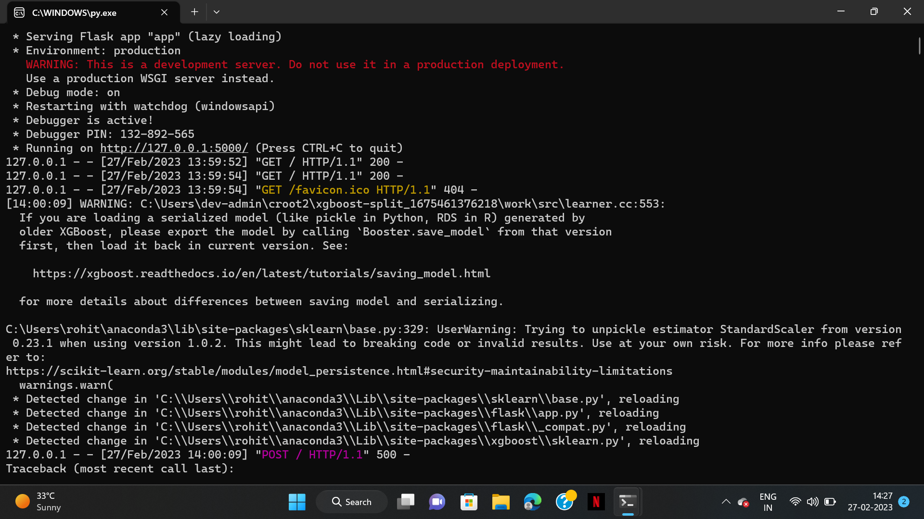

Screenshot 5.1: Running the Application

**5.3: User Interface of the Application**

User interface of the application after opening



Screenshot 5.3: User Interface of the Application

**5.4: Input values**

Input values in Potability Checker

Here we are taking a values from a river water.



Screenshot 5.4: Input values

**5.5: Result of input Values**

Result for given water sample is portable

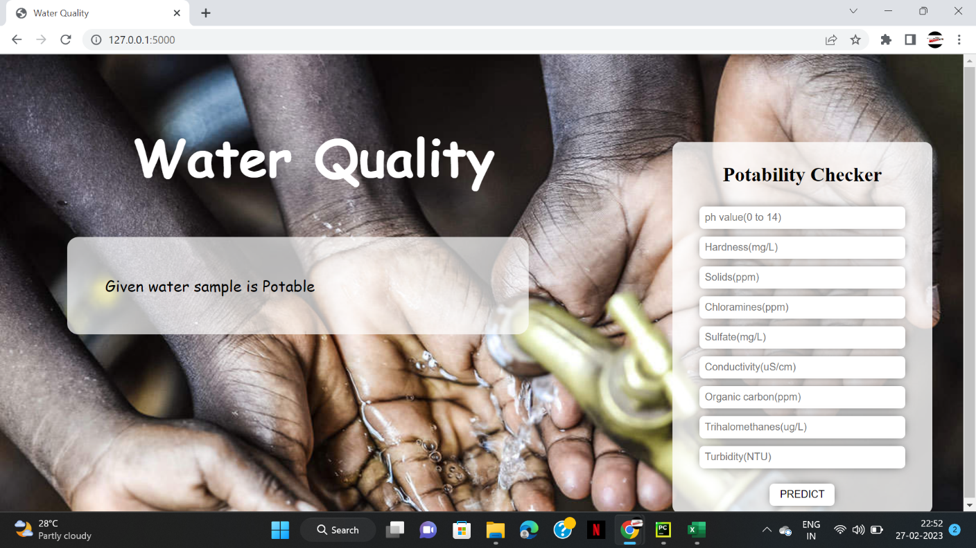

Screenshot 5.5: Result of input values the given water sample is portable

**5.6: Result of input values**

Here we took values of pond water. Result for given water sample is not portable

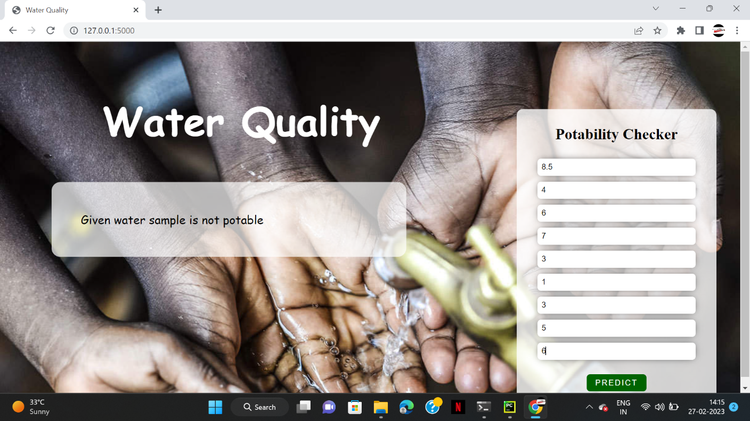

Screenshot 5.6: Result for given water sample is not portable

**6. TESTING**

**6. TESTING**

##### 6.1 INTRODUCTION TO TESTING

The purpose of testing is to discover errors. Testing is the process of trying to discover every conceivable fault or weakness in a work product. It provides a way to check the functionality of components, subassemblies, assemblies and/or a finished product. It is the process of exercising software with the intent of ensuring that the Software system meets its requirements and user expectations and does not fail in an unacceptable manner. There are various types of tests. Each test type addresses a specific testing requirement.

##### TYPES OF TESTING

* + 1. UNIT TESTING

Unit testing involves the design of test cases that validate that the internal program logic is functioning properly, and that program inputs produce valid outputs. All decision branches and internal code flow should be validated. It is the testing of individual software units of the application .It is done after the completion of an individual unit before integration. This is a structural testing that relies on knowledge of its construction and is invasive. Unit tests perform basic tests at component level and test a specific business process, application and/or system configuration. Unit tests ensure that each unique path of a business process performs accurately to the documented specifications and contains clearly defined inputs and expected results

6.2.2 INTEGRATION TESTING

Integration tests are designed to test integrated software components to determine if they actually run as one program. Integration tests demonstrate that although the components were individually satisfactory, as shown by successfully unit testing, the combination of components is correct and consistent. Integration testing is specifically aimed at exposing the problems that arise from the combination of components.

6.2.3 FUNCTIONAL TESTING

Functional tests provide systematic demonstrations that functions tested are available as specified by the business and technical requirements, system documentation, and user manuals.

Functional testing is centered on the following items:

Valid Input : identified classes of valid input must be accepted.

Invalid Input : identified classes of invalid input must be rejected.

Functions : identified functions must be exercised.

Output : identified classes of application outputs must be exercised.

Systems/Procedures : interfacing systems or procedures must be invoked. Organization

and preparation of functional tests is focused on requirements, key functions, or special

test cases.

##### TEST CASES

* + 1. CLASSIFICATION

|  |  |  |  |  |  |  |  |
| --- | --- | --- | --- | --- | --- | --- | --- |
| Test | Test Case | Test Case | Test Steps | | | Test | Test |
| Case | Name | Description | Step | Expected | Actual | Case | Priority |
| Id |  |  |  |  |  | Status |  |
|  |  |  |  |  |  |  |  |
| 01 | Start the | Host the | If it | We | The | High | High |
|  | Application | application | doesn't | cannot | application |  |  |
|  |  | and test if it | Start | run the | hosts |  |  |
|  |  | starts |  | Application | success. |  |  |
|  |  | making sure |  | . |  |  |  |
|  |  | the required |  |  |  |  |  |
|  |  | software is |  |  |  |  |  |
|  |  | available |  |  |  |  |  |
| 02 | Home Page | Check the | If it | We | The | High | High |
|  |  | deployment | doesn’t | cannot | application |  |  |
|  |  | environment | load. | access | is running |  |  |
|  |  | for |  | the | successfully |  |  |
|  |  | properly |  | application | . |  |  |
|  |  | loading the |  |  |  |  |  |
|  |  | application. |  |  |  |  |  |
| 03 | User | Verify the | If it | We | The | High | High |
|  | Mode | working of | doesn’t | cannot | application |  |  |
|  |  | the | Respond | use the | displays the |  |  |
|  |  | application |  | Freestyle | Freestyle |  |  |
|  |  | in freestyle |  | mode. | Page |  |  |
|  |  | mode |  |  |  |  |  |
| 04 | Data Input | Verify if the | If it fails | We | The | High | High |
|  |  | application | to take the | cannot | application |  |  |
|  |  | takes input | input or | proceed | updates the |  |  |
|  |  | and updates | store in | further | input to application |  |  |
|  |  |  | The |  |  |  |  |
|  |  |  | Database |  |  |  |  |

**7. CONCLUSION**

##### 7. CONCLUSION & FUTURE SCOPE

##### 7.1 PROJECT CONCLUSION

In this study, water quality model was implemented using decision tree technique. The analysis of water Alkalinity level and conductivity can play a major role in assessing water quality. Five decision tree classifiers which are J48,LMT,Random forest, Hoeffding tree and Decisions ump were used to build the model and the accuracy compared. J48 decision tree had the highest accuracy of 94% with Decisions ump having the lowest accuracy of 83%.The decision tree classifier provided with quality water parameters set by WHO and KEBS can be used to predict whether drinking water is clean or not.

##### FUTURE SCOPE

Although our models It is recommended that further studies be carried out towards involving biological and weather parameters in the water quality model development as this will ensure that a wider range of contamination sources is achieved. Hybrid models will work better for water quality prediction where minimal parameters are used for analysis. Stakeholders should develop a foul proof plan that will make essential information and strategies available to help mitigate contamination in water bodies early enough.

### 

### 8. BIBLIOGRAPHY

##### 8. BIBLIOGRAPHY

##### 8.1 REFERENCES

1. Karanfil, O., & Konar, A. (2018). Development of a decision tree-based classification model for surface water quality. Environmental Monitoring and Assessment, 190(3), 171.
2. Saravi, S. S. S., & Malekian, A. (2019). Application of decision tree algorithm for prediction of water quality index (WQI). Journal of Water and Land Development, 43(1), 18-27.
3. Esakkirajan, M., & Thanushkodi, K. (2017). Decision tree based approach for water quality classification using WQI parameters. Journal of King Saud University-Engineering Sciences, 29(4), 318-324.
4. Ferreira, R. B., Lopes, J. A., & Ribeiro, R. (2018). Decision trees for monitoring and management of water quality in small and medium-size water supply systems. Water Science and Technology: Water Supply, 18(6), 2006-2013.
5. Jha, P., & Kumar, R. (2016). A novel decision tree approach for water quality prediction in rivers. Journal of Hydroinformatics, 18(1), 116-131.
6. Wang, Y., Zhan, C., Li, M., Chen, G., & Liu, Y. (2019). An improved decision tree method for water quality assessment of rivers. Journal of Cleaner Production, 210, 1001-1012.
7. Chatterjee, D., & Panchal, V. (2019). Water quality assessment of Ganga River basin using decision tree analysis. Environmental Earth Sciences, 78(19), 578.
8. Baskaran, R., & Muthusaravanan, S. (2018). An intelligent system for water quality analysis using decision tree algorithm. Applied Water Science, 8(5), 141.
9. Patil, S. S., & Jena, S. K. (2017). Decision tree algorithm based classification of water quality data. Procedia Engineering, 173, 506-513.

### 

### 9. PAPER PUBLICATION